**Types of graphs in Matplotlib**

Matplotlib, a popular Python library for data visualization, supports various types of graphs. Here are some important types:

1. Line plot:

python

import matplotlib.pyplot as plt

plt.plot(x, y)

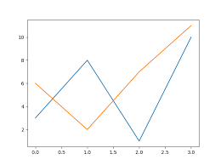

2. Bar plot:

python

import matplotlib.pyplot as plt

plt.bar(x, height)

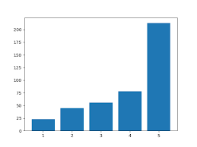

3. Histogram:

python

import matplotlib.pyplot as plt

plt.hist(data, bins)

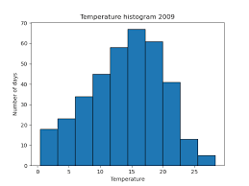

4. Scatter plot:

python

import matplotlib.pyplot as plt

plt.scatter(x, y)

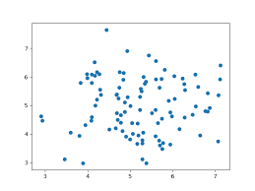

5. Pie chart:

python

import matplotlib.pyplot as plt

plt.pie(values, labels)

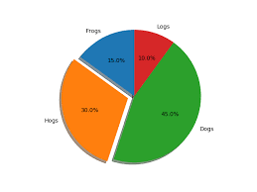

6. Box plot:

python

import matplotlib.pyplot as plt

plt.boxplot(data)

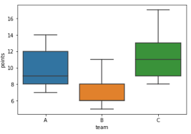

7. Violin plot:

python

import matplotlib.pyplot as plt

plt.violinplot(dataset, positions)

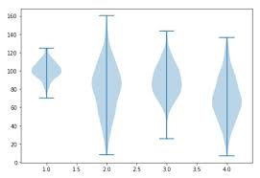

8. Heatmap:

python

import matplotlib.pyplot as plt

plt.imshow(data, cmap)

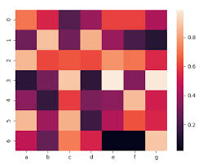

9. 3D plot:

python

from mpl_toolkits.mplot3d import Axes3D

import matplotlib.pyplot as plt

fig = plt.figure()

ax = fig.add_subplot(111, projection='3d')

ax.scatter(x, y, z)

